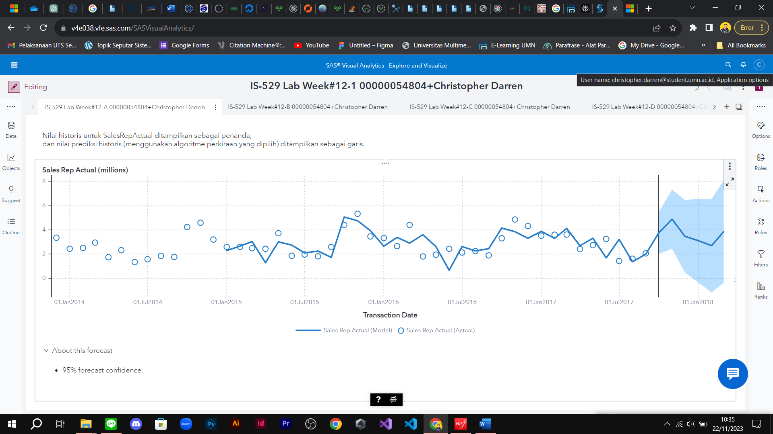

Figure A

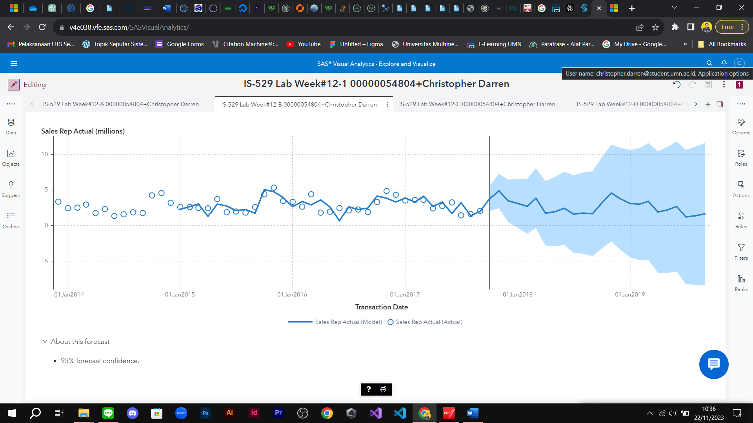

Figure B

**When you the results, explain what the difference is with output figure A ?**Bagian A hanya melibatkan peramalan selama 6 bulan mendatang, sementara pada Bagian B, peramalan dilakukan untuk periode 24 bulan ke depan, yang setara dengan dua tahun.

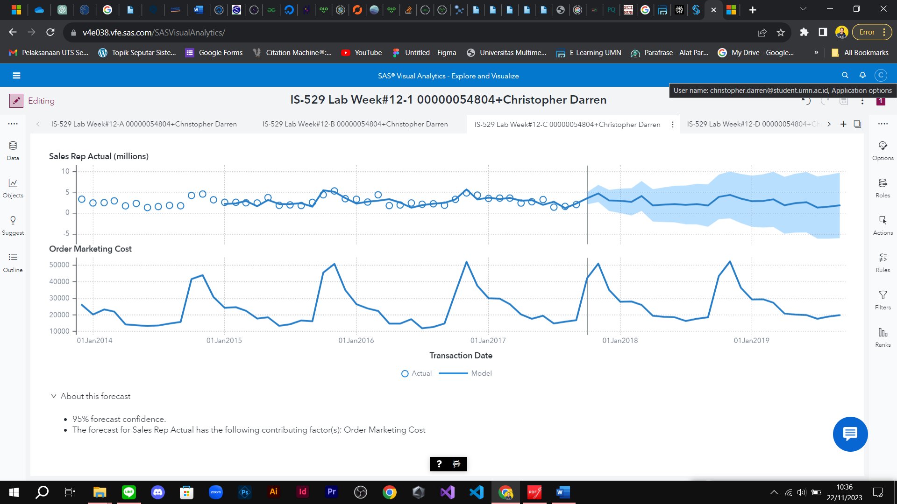

Figure C

**When you the results, explain what the difference is with output figure C ?** Pada bagian B melakukan forecasting SalesRepActual saja. Sedangkan pada bagian C melakukan forecasting *SalesRepActual* dan *OrderMarketingCost*. Tentu hasilnya juga akan berbeda.

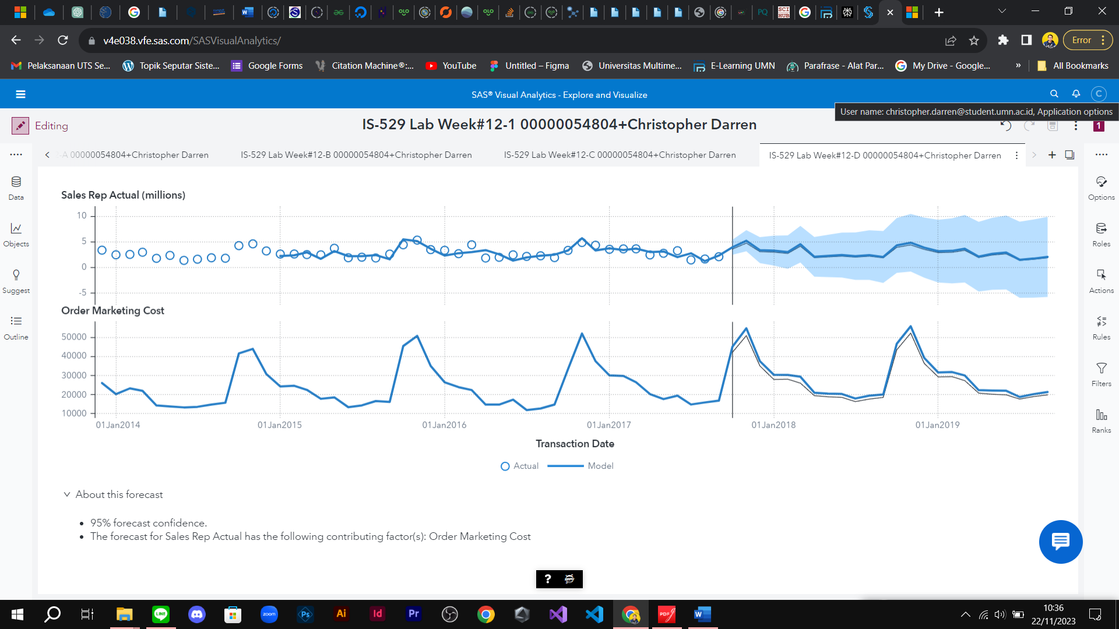

Figure D

**What insights did you gain from these outputs**? Meningkatkan prediksi sales sebanyak 10%

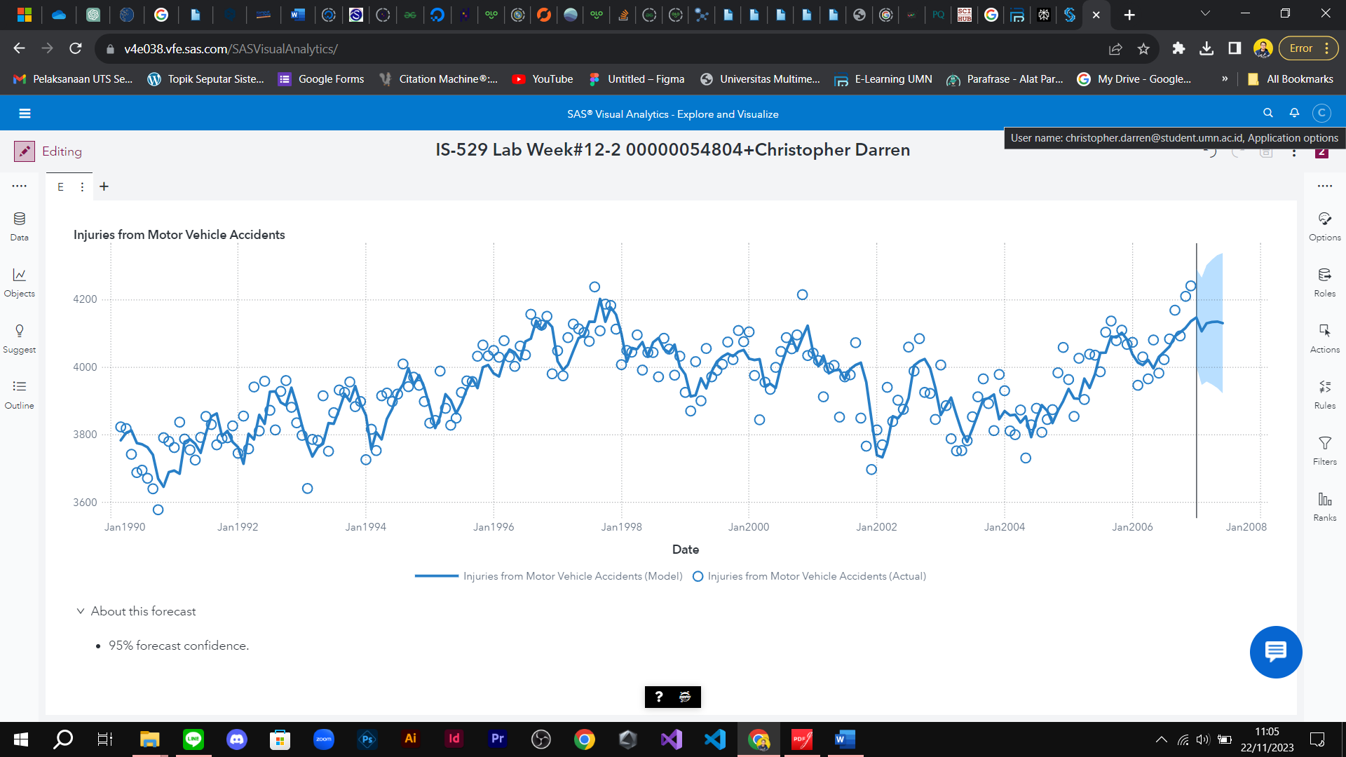

Figure E

**Which algorithm is selected for the forecast?**Seasonal Exponential Smoothing

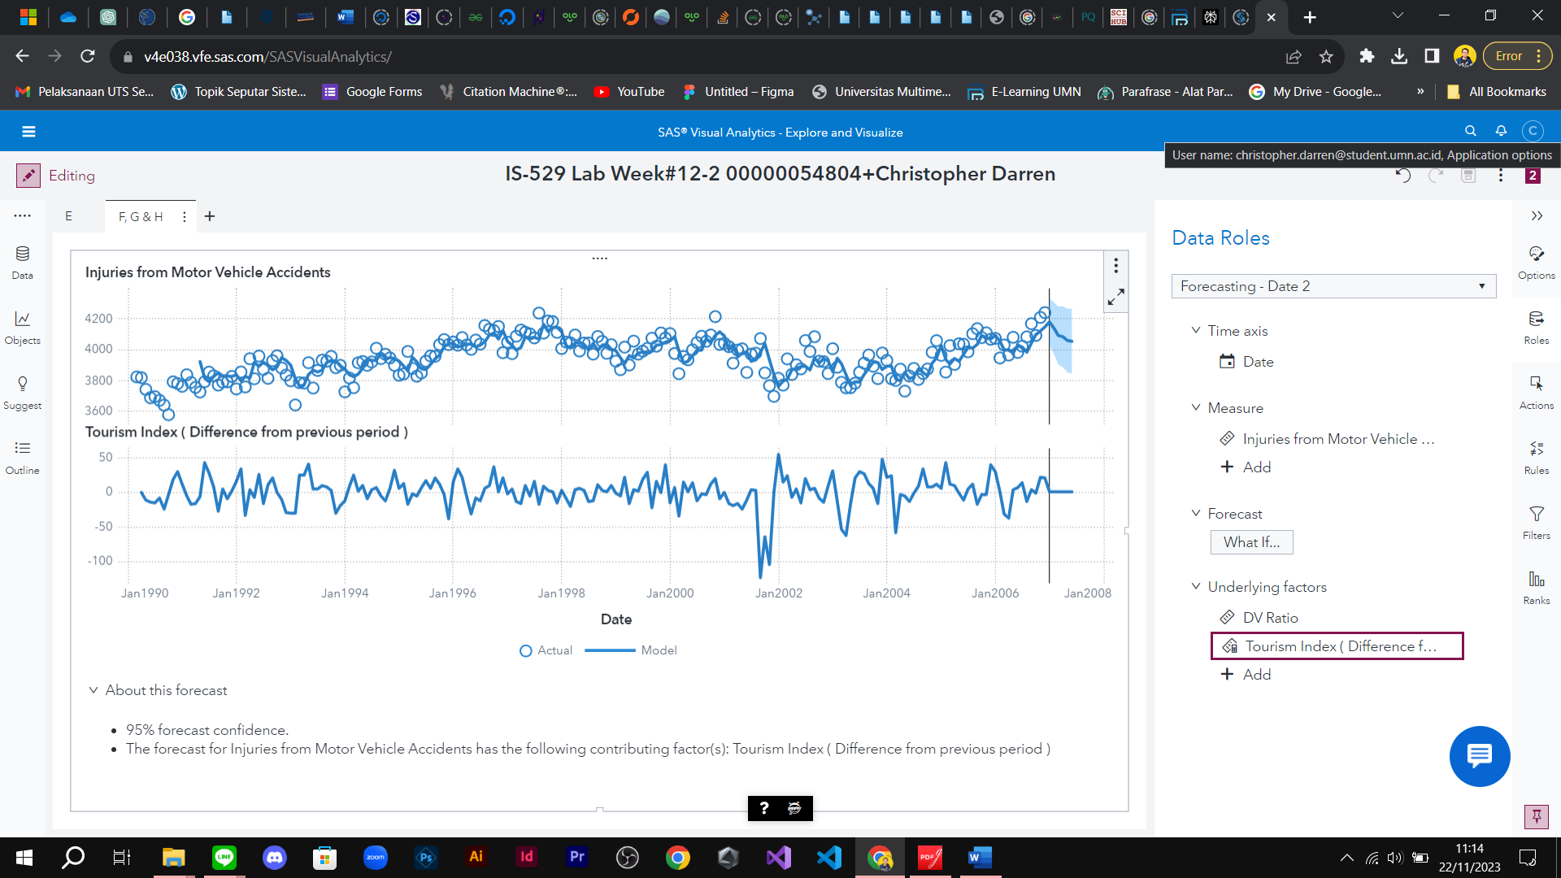

Figure F

**Which measures, if any, were selected as underlying factors and applied to the forecast?**

DV Ratio and Tourism Index ( Difference )

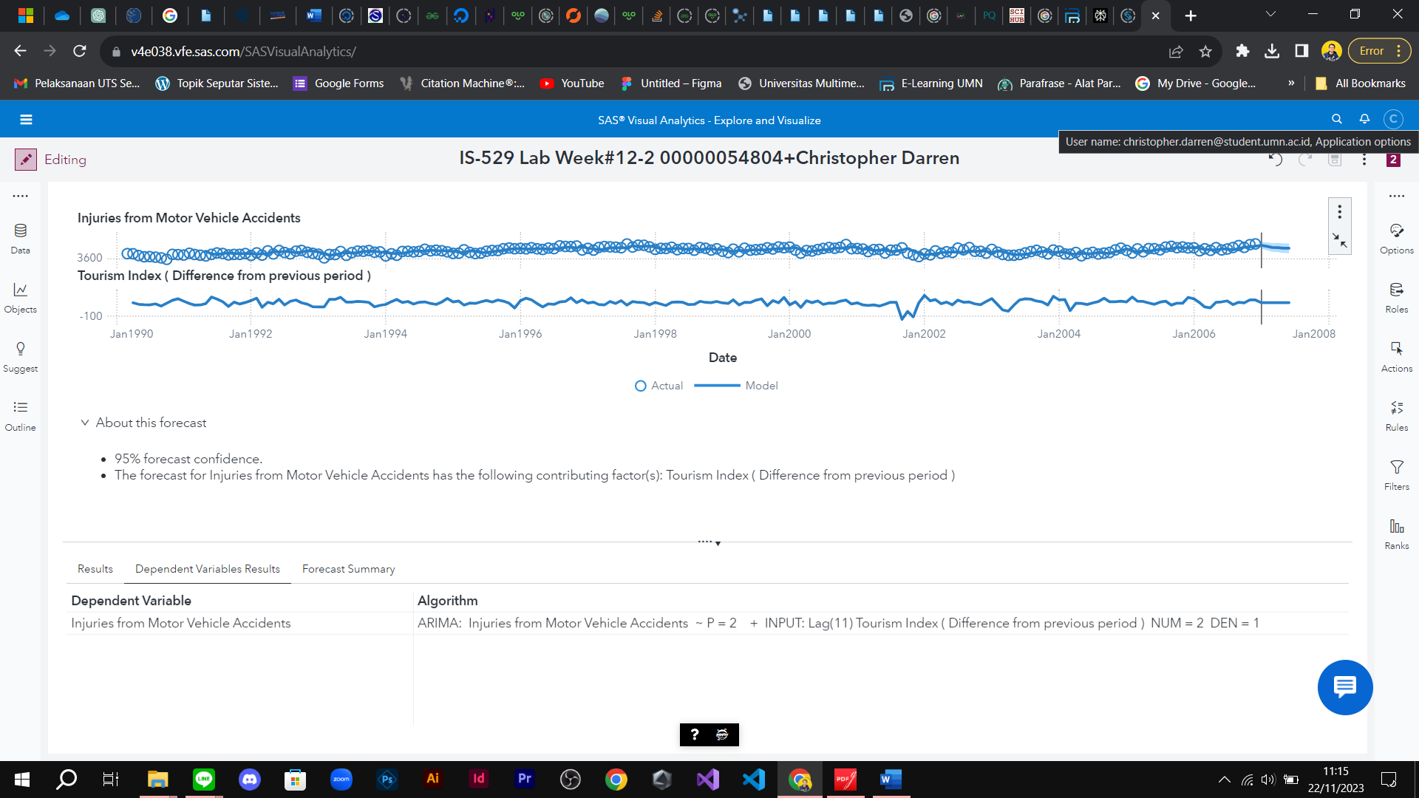

Figure G

**Which algorithm is now selected for the forecast?**

ARIMA

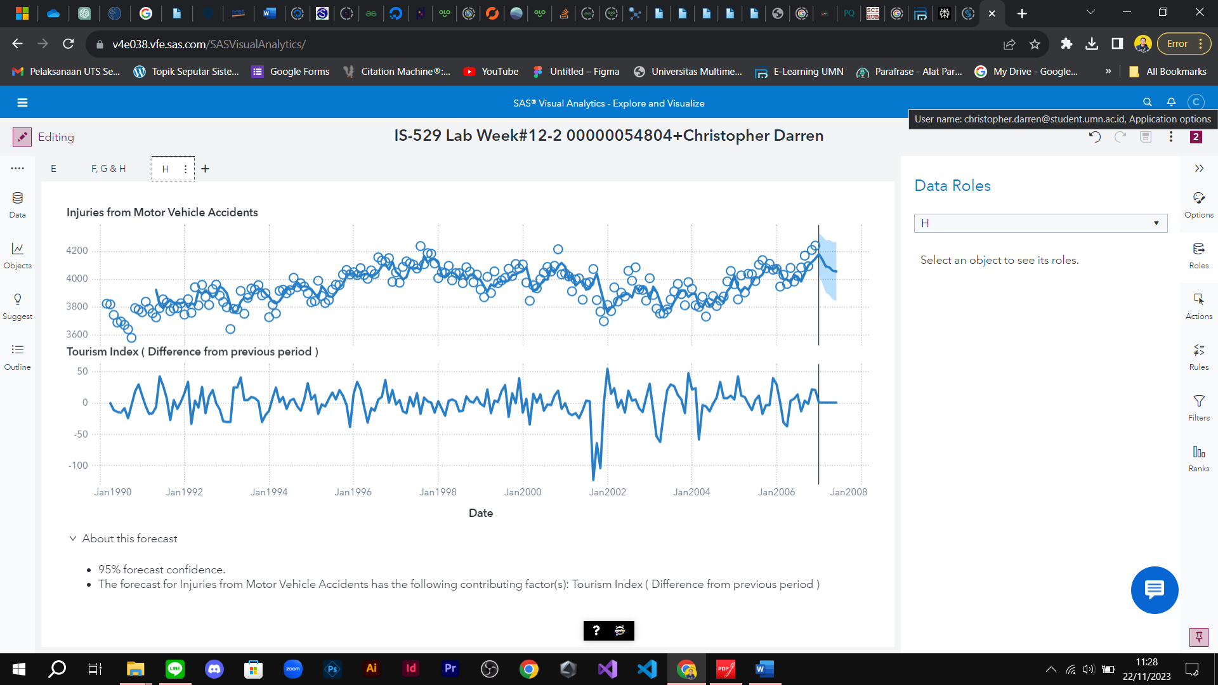

Figure H

**How does increasing the underlying factor impact the forecast?**by adding constant value by 10